**2020 ESS 132: Terrestrial Hydrology Homework 1**

You are welcome to work together on this homework to understand the concepts but your answers and workings must be in your own words. Group answers are not acceptable. Your completed homework is due by 11.59p.m. on Friday of Week 2 (Oct 16th). You can submit either as a .doc, .pdf, or you can take pictures and submit as .jpg or .png if you prefer to complete your homework on paper.

**Part A: Water chemistry (3)**

Why does water have such a high specific heat? How does water’s high specific heat affect regional climate? (3)

The polar nature of individual water molecules allows water to have a high specific heat. Water molecules are comprised of hydrogens bonded to oxygen, and given that oxygen is the second most electronegative element in the periodic table, it strongly attracts electrons in the covalent bonds between oxygen and hydrogen. The bent nature of water is due to the lone pairs of electrons on oxygen pushing away the electron pairs involved in bonds between oxygen and hydrogen. The electronegative nature of oxygen and the bent shape of water molecules results in a net dipole where the oxygen end of water is much more negative than the hydrogen end, allowing for hydrogen bonds to form between the oxygen end of a water molecule with the hydrogen ends of other water molecules. These hydrogen bonds are strong intermolecular forces and require a lot of energy to weaken or break. As a result, water needs to absorb high amounts of heat in other to weaken these hydrogen bonds to move faster and increase in temperature.

Water’s high specific heat helps to limit diurnal and annual temperature ranges in coastal areas. During the day, seawater absorb large amounts of heat without significantly changing in temperature, cooling air over the sea and creating a low pressure region over the sea. Since the land surface has lower specific heat, it reaches higher temperatures than seawater during the day, heating air over land and creating a low pressure region on the surface. This creates a pressure gradient that drives cool air from the high pressure region over the sea towards land, cooling daytime temperatures. At night, seawater becomes warmer than the land surface, reversing the pressure gradient so that cool air from land flows out to the sea, preventing land temperatures from dropping too low. As a result, the high specific heat of seawater limits diurnal temperature ranges.

**Part B: Stream networks (5)**

Watershed A consists of bedrock that is more porous and permeable (i.e. the rock contains more pore space and those pores are very connected) than Watershed B. Otherwise they are the same shape and size.

1. How might you expect the drainage network (e.g. drainage density, number of channels, max Strahler stream order) to differ between Watershed A and B? (3)

Water would infiltrate into the soil and underlying groundwater at higher rates in watershed A, resulting in lower number of stream channels in watershed A, which would lower drainage density in watershed A. Max Strahler stream order would also be lower in watershed A due to the lower number of streams.

1. Which watershed would be more at risk of large flood events and why? (2)

Watershed B would be more at risk of flood events because surface water would be more likely to run off into streams than infiltrate into soil, which can overwhelm stream channels and cause them to flood.

**Part C: Watershed delineation (10)**

Below is a topographic map of a section of Yosemite National Park. Delineate the watershed of the stream that flows into Washburn Lake (marked by the red circle). (10)

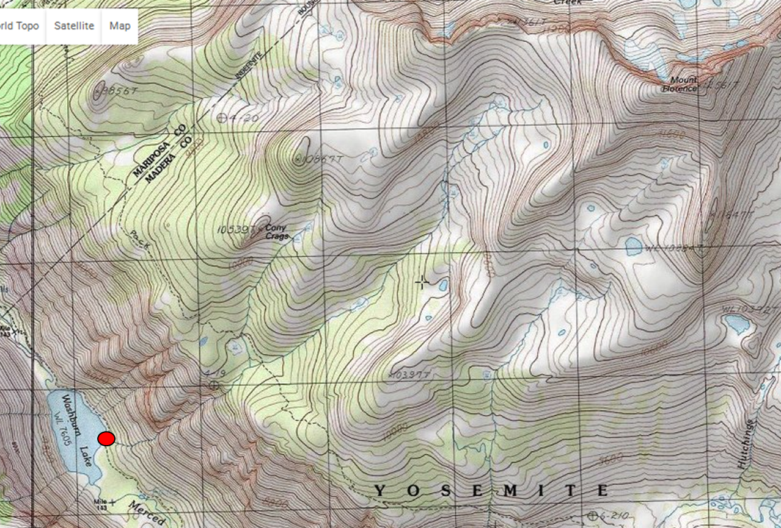

**Part D: Water mass balance equation (13)**

Consider a watershed with an area of 1,800,000 m2. Between 2000-2010 it received an average annual precipitation of 0.8 m yr-1 and saw an average stream discharge of 70 m3 hr-1. Assume no significant amount of water leaves the watershed as groundwater or due to human diversions.

(Show your workings to earn full credit!)

a) What is the total volume of precipitation that falls over 1 year? (2)

Annual precipitation (0.8 m yr-1) x watershed area (1,800,000 m2) = Volume (1,440,000 m3/yr)

Volume = 1,440,000 m3

b) What is the total volume of stream discharge over 1 year? (2)

Volume = 613,200 m3

c) What is the average annual evapotranspiration rate in mm/day? (4)

Q = streamflow rate; P = precipitation rate; ET = evapotranspiration rate; S = land water storage; all units are in volume/time

Evapotranspiration rate = 1.26 mm/day

d) What major assumptions are you making about this watershed in order to calculate the evapotranspiration rate above? (2)

Assumption 1 (well this is already given in the problem): that groundwater flows into and out of watershed are negligible and so can be eliminated from the water balance equation

Assumption 2 (well this is also given): that changes in water storage in this watershed are insignificant

e) GRACE measurements have substantially changed the way we use water balance equations at larger scales. Explain what the GRACE satellites measure and how. (3)

GRACE satellites measure the amount of water stored in watersheds by observing how changes in gravity affect the distance between the 2 satellites. As the satellites approach a massive object on the surface (presumably a watershed with large amounts of groundwater or a snowpack with large amounts of snow), the leading satellite accelerates due to the large gravity from the surface object and the distance between the satellites grow. As the second satellite approaches the object, it starts to accelerate as well, reducing the distance between the 2 satellites. Changes in the distance between the satellites are used to estimate the amount of water storage in various watersheds.

**Part E – Atmospheric moisture calculations (8)**

1. Using the following information and formulae, calculate the air temperature in the Central Valley.(4)

Relative Humidity in the Central Valley = 38%

Dew point temperature of air = 1 oC

Relative humidity = actual vapor pressure x 100%

saturation vapor pressure

where T = temp (oC) and e* = saturation vapor pressure (Pa)

The temperature in the Central Valley is approximately 15.19°C.

1. On a separate day, the air temperature at the ground surface is 25 oC, and the dew point temperature is 4 oC.
2. How far would air have to rise before clouds begin to form? (2)

Assuming that the dew point does not change temperature as an air parcel rises

An air parcel would need to rise by 2.1 km before it forms a cloud.

1. What would the temperature of rising air be at 4 km above the ground? (2)

Rising air would be at a temperature of -6.45°C at 4 km above the ground.

**Part F: Moisture recycling and the Amazon fires (11)**

Whenever possible, it is a good idea to practice reading the primary literature and to keep up to date with hydrologic research and current events. Below are 2 links - the first is to a brief review of recent scientific advances regarding moisture recycling in the Amazon. The second is a longer article intended for the general public explaining why the fires in the Amazon should concern us, as well as the political context and potential policy solutions. Please use your own words to answer the questions (i.e. don’t just use sentences taken from the articles!).

<https://advances.sciencemag.org/content/4/2/eaat2340.short>

<https://www.vox.com/2019/8/27/20833275/amazon-rainforest-fire-wildfire-dieback>

1. Why is the influence of vegetation on rainfall greater in the eastern part of the Amazon basin compared to the western part (near the Andes)? (1)

The western part receives rainfall from the Pacific Ocean while the Andes prevents air from the Pacific Ocean to cause rainfall on the eastern part of the Amazon basin. As a result, vegetation has a smaller influence on rainfall on the western part of the basin due to the influence of the Pacific Ocean on this part of the basin, yet the Amazon rainforest has a greater influence on rainfall on the eastern part of the basin far from the Andes and so far from the influence of the Pacific Ocean.

1. Explain why increasing rates of deforestation and wildfire in the Amazon basin should concern both local people and the wider global community. (2)

Both remove vegetation, which decreases the amount of rain that is recycled in the region. As a result, rainfall in the region will decrease, potentially causing droughts and fluctuating agricultural output that can cause economic instability to the region. In addition, both processes, in removing vegetation, potentially causes ecosystem changes that decrease the ability of the Amazon basin to serve as a carbon sink and can potentially cause the basin to become a carbon source instead, exacerbating climate change.

1. What is the positive feedback loop(s) described in the article between vegetation and precipitation that can lead to a shrinking Amazon rainforest. (3)

As vegetation decreases due to wildfires, deforestation, and climate change, the amount of rainfall being recycled in the region decreases, and so precipitation decreases. This can cause further decreases in vegetation, which will cause further decreases in vegetation.

1. Why has there been a recent resurgence in the number of wildfires in the region? What is thought to be the climate change tipping point? (3)

A resurgence of wildfires in the region took place after Jair Bolsonaro became president of Brazil in April 2019. This resurgence was caused by policy changes under his presidency that allows for deforestation and frequency of fires to increase.

The climate change tipping point, according to the editorial, is roughly 20-25% deforestation. Once approximately this amount of land in the Amazon basin is deforested, some scientists think that ecosystem changes on the basin are irreversible, potentially causing the Amazon basin to completely change its ecosystem type, which can affect the economy of the region and can also cause the Amazon to be a net source of carbon.

1. What are the various policy options proposed in the second article that could address the problem? (Note that there is a mistake in the article in this section – bonus point for spotting it!) (2)

The policy options include measures that allow the local population to adapt to the possible effects of the region – e.g. better water management – to measures that mitigate the loss of the rainforest to deforestation and wildfires – e.g. reducing deforestation, no-fire agriculture.

The mistake is in saying “reducing reforestation” instead of “reducing deforestation.”